**REPORT VIEW –**

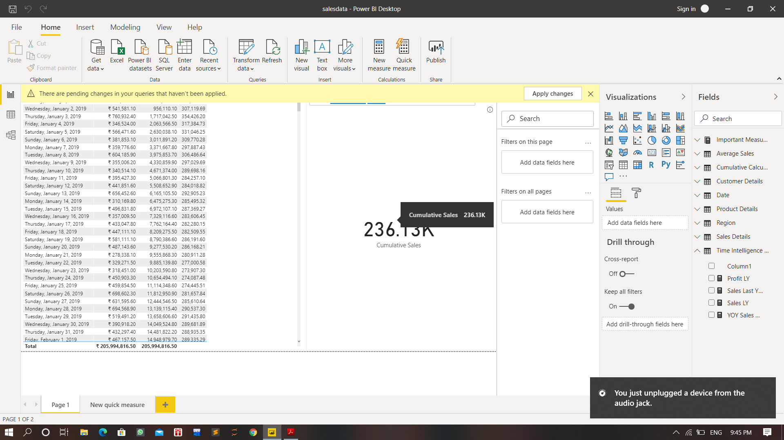

**DATA VIEW –**

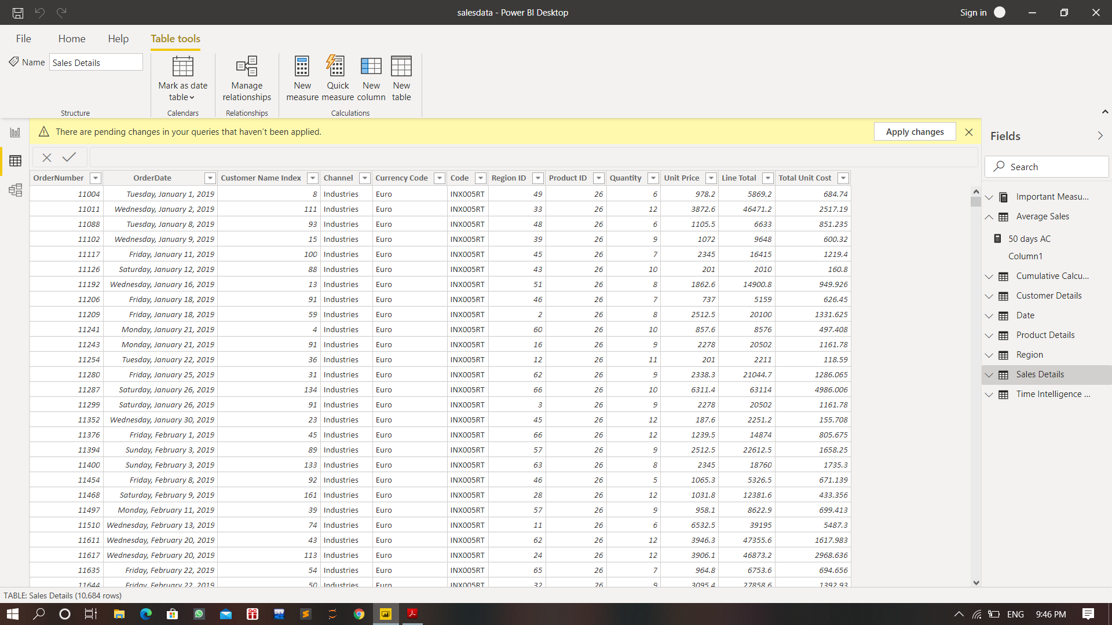

**MODEL VIEW –**

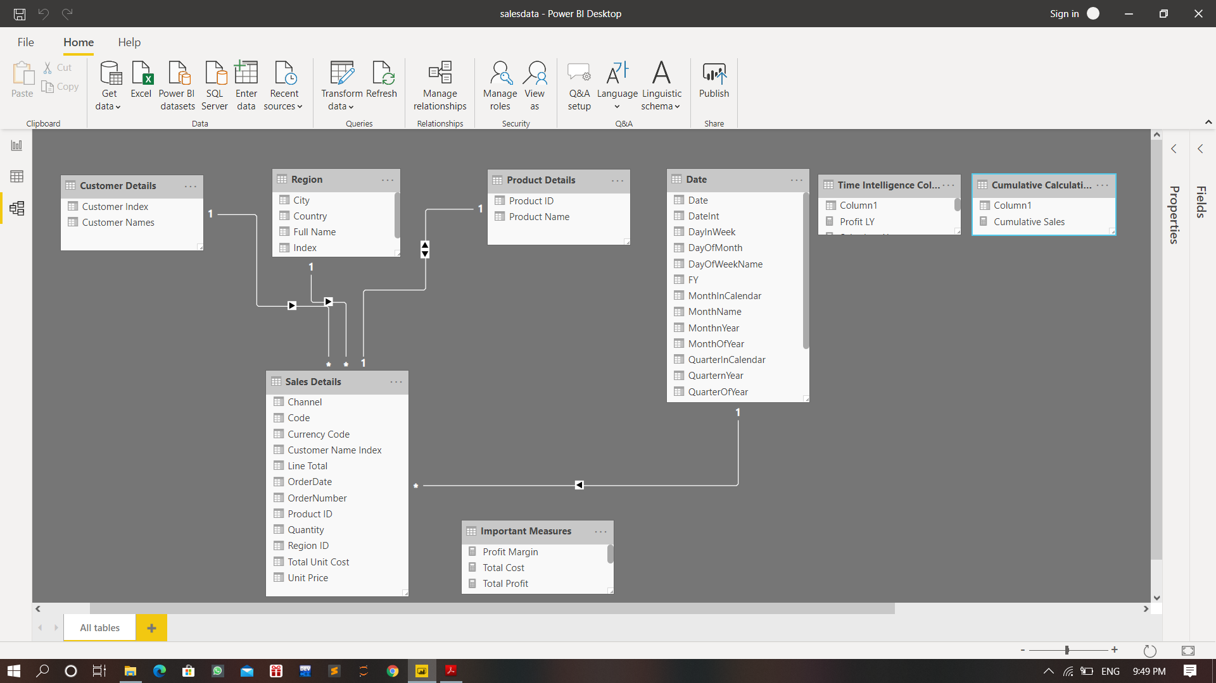

**POWER QUERY EDITOR –**

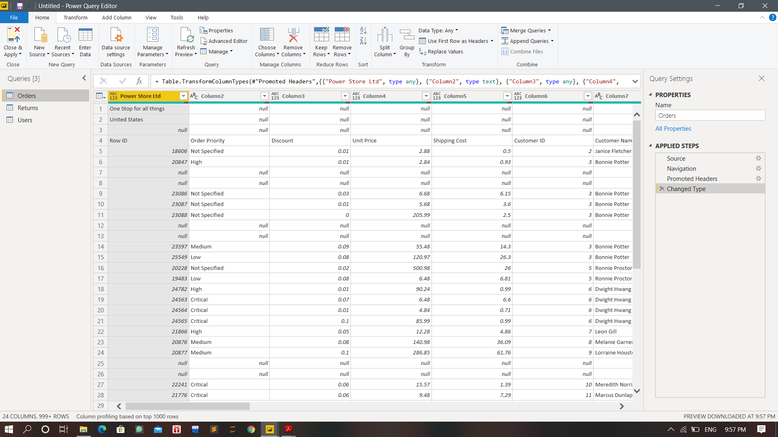

**ADVANCE EDITOR –**

